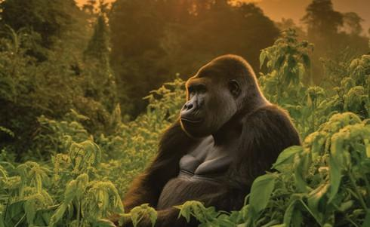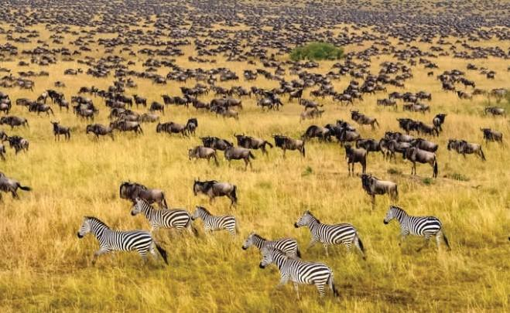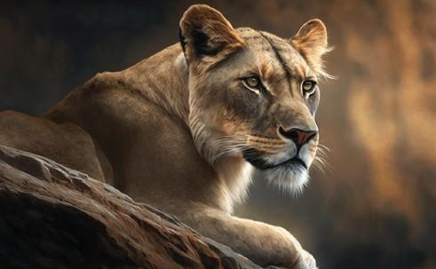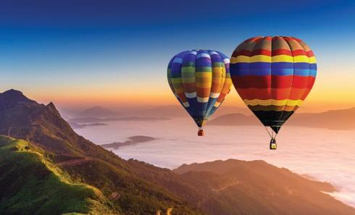

UGANDA

3 DAY GORILLA TREKKING EXPERIENCE IN UGANDA

Uganda is a place of extraordinary sights and unlimited adventure. The home of lofty peaks and giant fauna; of wild rivers and sweeping savannahs. It is where fantasies are set, and memories are made.

Bwindi Impenetrable National Park Bwindi is the habitat of more than half the world’s population of Mountain Gorillas with over 300 mountain gorillas living here, 346 bird species, and 200 butterfly species. The word “Bwindi” means “darkness” and taking a hike in this magnificent forest will certainly unveil to you the reason why the forest was named so. You will also be in a position to quickly tell why the forest is also regarded as Impenetrable. One is required to be physically fit to take part in this mountain gorilla tracking / trekking adventure because it may involve climbing steep terrain.

The Park has 4 Gorilla sectors, i.e., Ruhija, Rushaga, Buhoma, and Nkruringo, and a maximum of 8 people are allowed to trek each gorilla family.

NOTE: This itinerary provides for flying directly from Masai Mara to Kisoro for Gorilla Tracking, or for flying from Entebbe International Airport and then traveling by road in Kisoro for Gorilla Tracking for 3 days.

Travel Highlights
- Landing in Entebbe
- Flying to Kisoro Air Strip – Bwindi Impenetrable National Park Gorilla tracking
- Flying back to Entebbe

DETAILED ITINERARY

Landing at Entebbe International Airport using either Kenya Airways or Uganda Airways
You will have a connecting flight from Entebbe to Kisoro on that same day.
Your designated tour guide will meet you at Kisoro Airstrip with vital information about your tour/safari. You will then be transferred to a lodge in Kisoro where you will spend the night.
Kisoro airstrip is located in Kisoro district, just close to Bwindi Impenetrable Forest National Park and this is where your gorilla trekking activities will be

Activity | Details
Boarding to Kihihi / Kisoro Airstrip/ Entebbe | You will take the early morning flight.
Meet and Greet | Your tour guide will meet you at the airstrip. An English-speaking guide.
Transfer to the designated accommodation | Your guide will then drive you to the preferred choice of accommodation
Check-in | You will then check in, relax, have lunch and dinner.

Main Destination: Bwindi Impenetrable National Park
Accommodation: Midrange – 4 Gorilla Leisure Lodge / Gorilla Leisure Lodge OR Luxury– Nkuringo Bwindi Gorilla Lodge / Volcanoes Bwindi Lodge
Meals and drinks: Full Board

DAY 2:
Gorilla Trekking Travelers say there is no other wildlife encounter in Africa that compares to the outstanding experience of spending face-to-face time with Uganda’s wild gorillas in a natural setting. Seeing the sheer might yet gentleness of the silverbacks and the playful nature of the juveniles and infants is an unforgettable experience.
Gorilla treks begin at 8 AM every day with a briefing after which groups of a maximum of eight Tourists trek into the mysterious jungle. The trek can last anywhere from 1 hour to 3 hours depending on where the gorillas will be on a Specific day and you will be led by expert rangers and an experienced team of advanced trackers.
There is also a pleasant opportunity to see several other fauna and flora species, and birding along the way. Which gorilla trekking section you should choose for your adventure excursion will depend on where the gorilla permit will be available when making reservations.
After lunch, you will visit the Batwa community. The Buniga Forest Trail highlights the Batwa people’s historical connection with the Bwindi jungle before it became a protected reserve. Guided by the Batwa through their small forest pockets, guests gain insight into their unique heritage, traditions, and nomadic lifestyle

Activity | Details
Breakfast | Breakfast will be served early and Lunch will be packed.
Departure to BINP | Drive to the park head offices for a briefing session at 7:00 am.
Gorilla Trekking | Trekking can go on for approximately between 2 to 6 hours through the steep densely populated forested hills and then finally coming across depending on their movements
Gorilla trekking close-up | On reaching the gorillas you will be allowed to spend an hour with the gentle giant creatures.
Driving back to the Lodge | Upon completion of the magical encounter, you will walk back to the starting point where you will meet your driver and drive back to the Lodge.
Batwa Community visit | During the visit, you’ll explore a recreated Batwa settlement, watch women prepare traditional meals, meet medicine men, and learn about the medicinal uses of forest plants. You’ll also hear ancient legends, traditional songs, and discover their fascinating practices, from hunting and gathering to making fire with sticks.

Main Destination: Bwindi Impenetrable National Park
Accommodation: Midrange – 4 Gorilla Leisure Lodge / Gorilla Leisure Lodge OR Luxury – Nkuringo Bwindi Gorilla Lodge / Volcanoes Bwindi Lodge
Meals and drinks: Full Board

DAY 3
Transfer Back to Entebbe International Airport After a restful night and breakfast, your guide for the day will drive you to Kisoro Airstrip / Kihihi Airstrip, you will then board your flight back to Kenya or your preferred destination.
OR
Transfer back to Masai Maraa. Your guide for the day will drive you to Kisoro Airstrip to Board your flight back to Masai Maraa from Kisoro / Kihihi Airstrip.
Activity | Details
Breakfast | Breakfast at the lodge
Checkout | Checkout can be early or late on request.
Transfer to Kisoro Airstrip International Airport. | You will be taking the mid-morning flight to Entebbe
Arrival at Entebbe International Airport | You will then board to your preferred destination.

Main Destination: Entebbe International Airport
Meals and drinks: Bed and Breakfast

TOUR COSTS – QUOTED IN USD

NO OF PAX | 1 | 2 | 3 | 4 | 5 | 6
COST PER PERSON – 3 STARS | 3125 | 1577 | 3126 | 1577 | 1887 | 1577
COST PER PERSON – 4 STAR | 3603 | 1816 | 3602 | 1816 | 2173 | 1816
COST PER PERSON – 5 STAR | 5385 | 2707 | 5385 | 2707 | 3243 | 2707

What is Included
: • All Park fees
• All activities (Unless labeled as optional)
• All accommodation as per the options chosen
• A professional driver/guide
• All transportation in safari 4 X 4 vehicle with a pop-up roof
• All Taxes/VAT • Roundtrip airport transfer
• Meals (As specified in the day-by-day section)
• Complementary bottle of water per day while on safari

Package Excludes:
- International flights (From/to home)
- Visa
- Additional accommodation before and at the end of the tour
- Tips
- Personal items, Souvenirs, etc.
- Domestic flight
- Government-imposed increase of taxes and/or park fees
- Drinks
- Pottery fees
- Any Nightlife bills
